

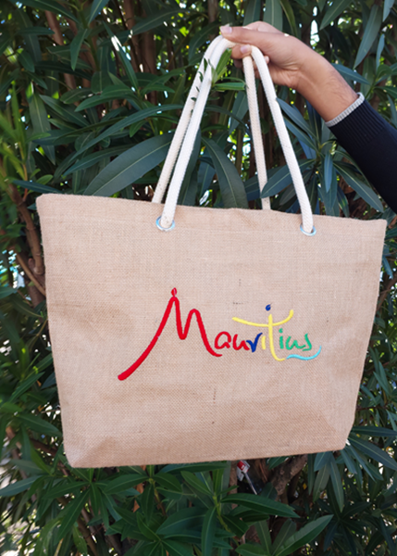



GAVIK CO LTD

EST 2015

The Content













Gavik Co Ltd proposes you unique and Eco-friendly products. We treat loyal customers with locally handmade products according to their requirements.

Our bags are designed for

the following occasions:



> Corporate Events

> Individual purpose

>Shopping

>Going to the beach

>Boutique hotels / local Boutique

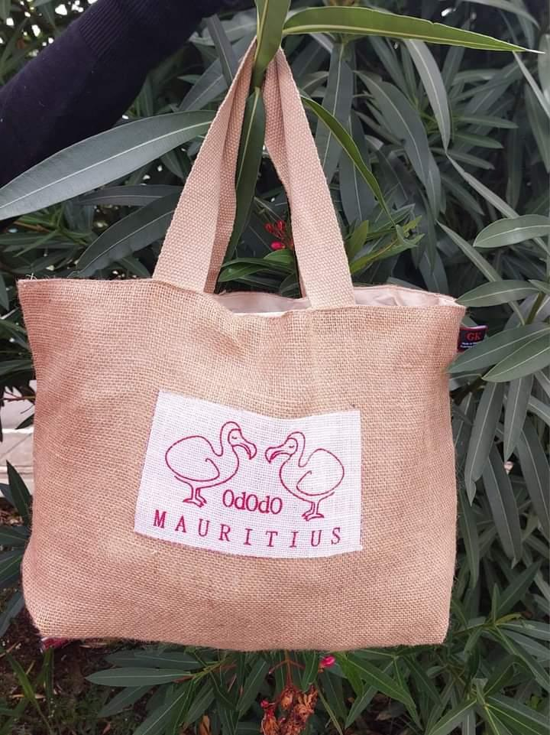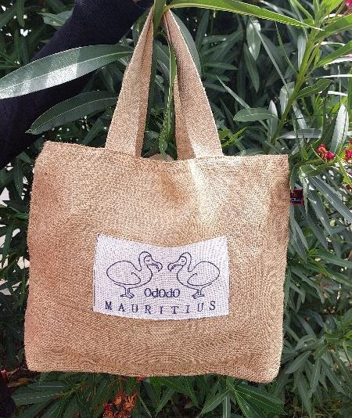





GAVIK CO LTD

EST 2015





GAVIK CO LTD

EST 2015

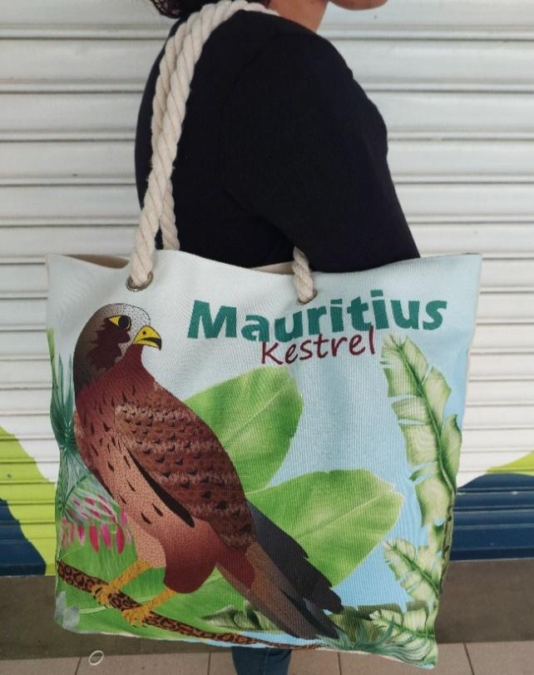

Juco Bag with Leather Handle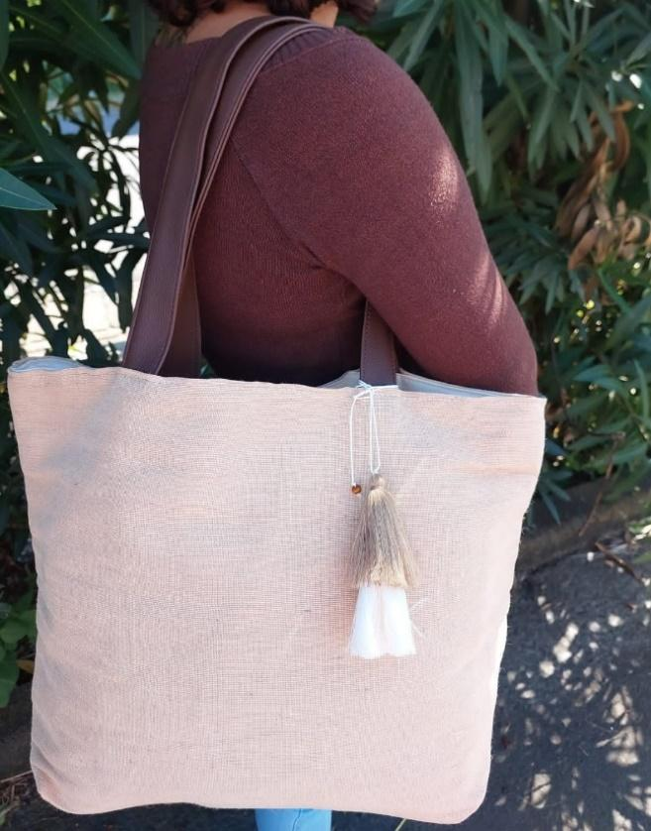

Dimension: 46cm(w) x 33cm(l)

Fabric: Juco and Leather

MOQ: 100pcs

Price: Rs 200

Our bags are locally made

Logo, Print or embroidery as per clients request.

GAVIK CO LTD

EST 2015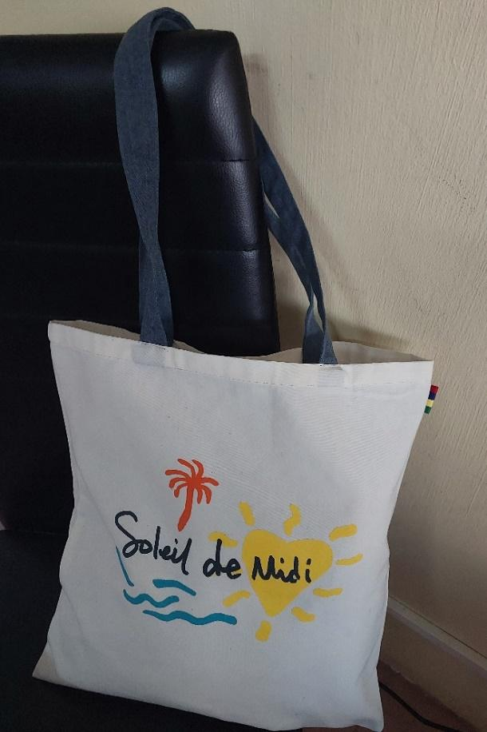

Cotton Bag

Dimension: 38cm(L) \*33cm(W)

Fabric: Cotton Fabric

MOQ: 100pcs

Price: Rs 190 exclusive vat

Our bags are locally made.

Logo, Print or embroidery as per clients request.

Canvas Cosmetic Bag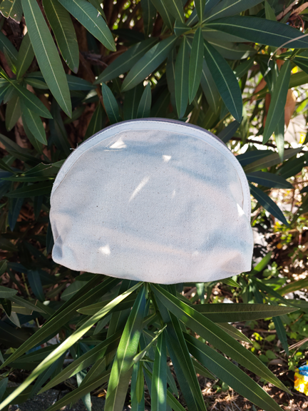

Dimension: 20cm(L) \*25cm(W)

Fabric: Canvas Fabric

MOQ: 100pcs

Price: Rs 150 exclusive vat

Our bags are locally made.

Logo, Print or embroidery as per client’s request.

GAVIK CO LTD

EST 2015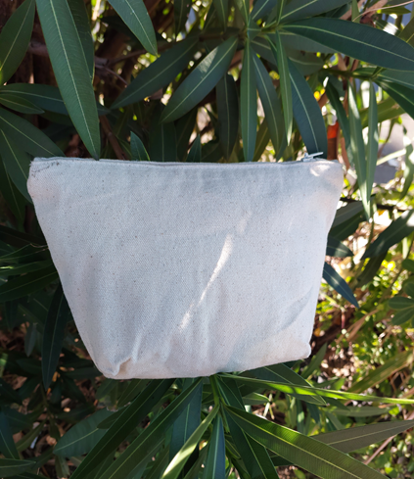

Canvas Cosmetic Bag

Dimension: 20cm(l) \*25cm(w)

Fabric: Canvas Cotton

MOQ: 100pcs

Price: Rs 150 exclusive vat

Logo, Print or embroidery as per client’s request.

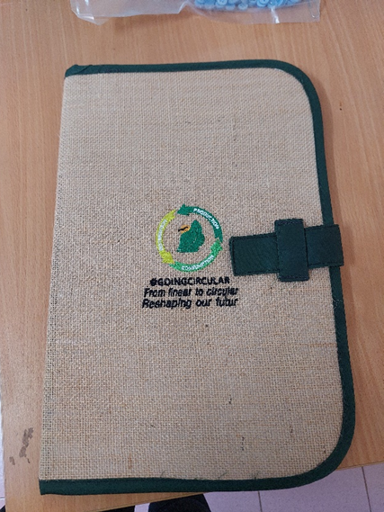

Eco Folder

Dimension: 36(l) \* 24cm(w)

Fabric: Jute

MOQ: 100pcs

Price: Rs 250 exclusive vat

Our products are locally made

Logo, Print or embroidery as per clients request.

GAVIK CO LTD

EST 2015

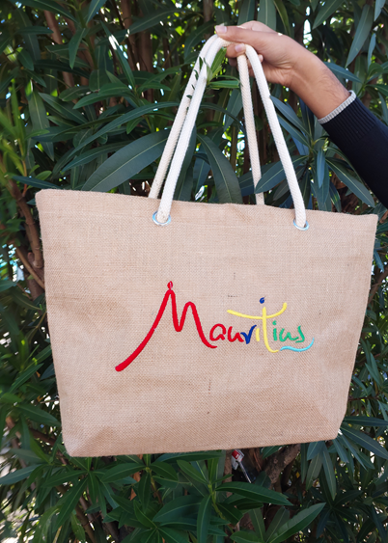



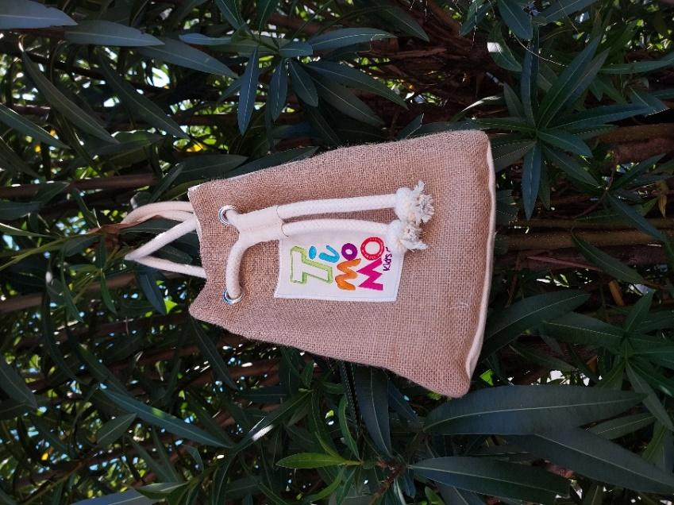

GAVIK CO LTD

EST 2015

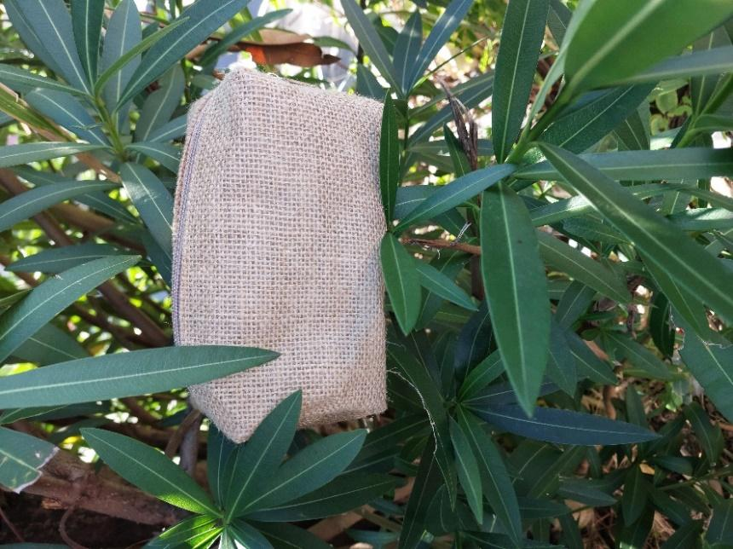



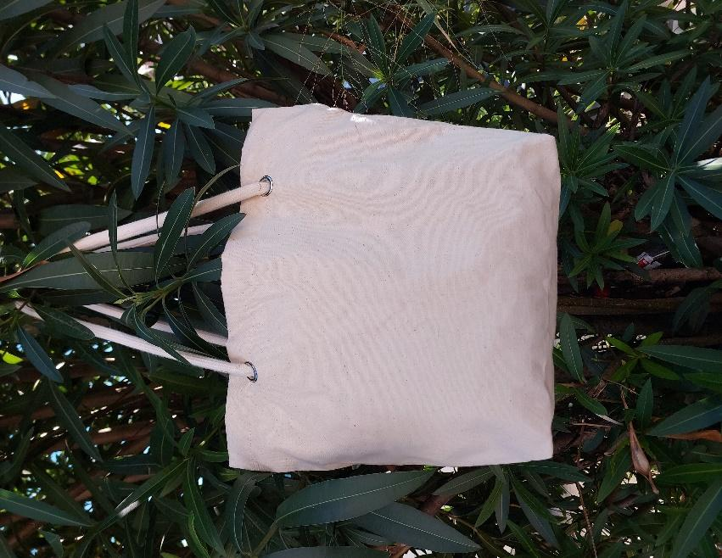

GAVIK CO LTD

EST 2015

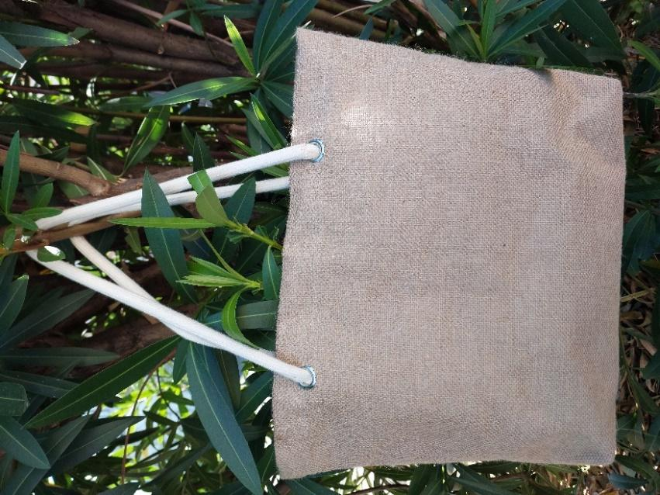

GAVIK CO LTD

EST 2015

*Contact Us* 